Date: 2024/04/14
Name: Siron Prajapati
Level 3 Semester 2 Computing Section ‘A’

- The perimeter of a rectangle with length 9 & width 6
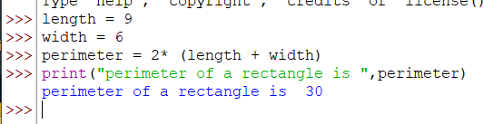
- Python is great, it’s wild!
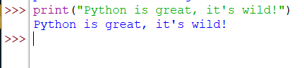
- 2 to the 10thpower
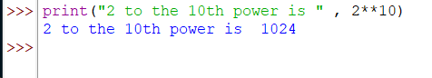
- 7 factorial minus 5 factorial
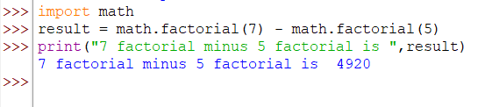
- Your forename multiplied by 5
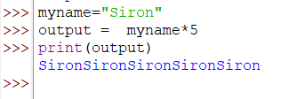
- Your name left justified 15 spaces
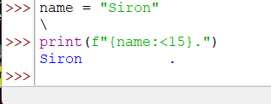

- PI to 5 decimal places
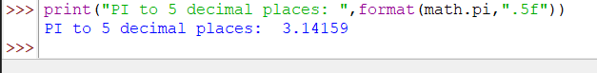
- 200 modulus 12
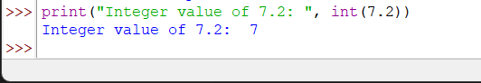
- 7.2 as an integer value
